ESTATE MANAGEMENT GRANT 2022

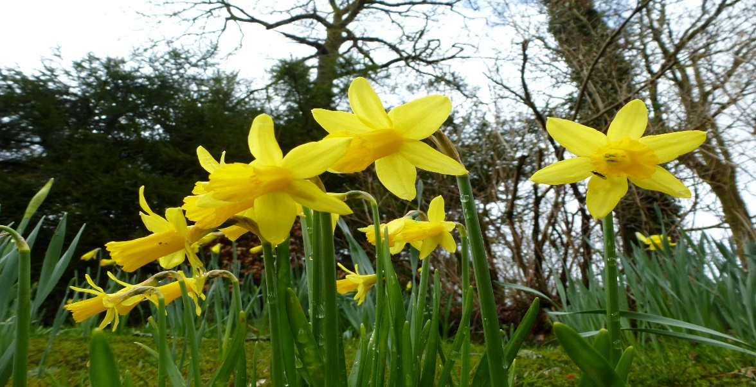

APPLICATION FORM
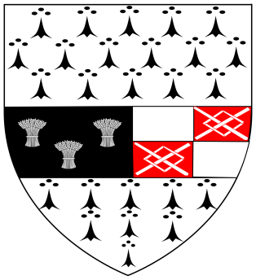

CLOSING DATE: Friday 25th March 2022 at 5.00pm

Name of Estate: ___________________________________________
Contact Name: ___________________________________________
Contact Address: ___________________________________________
______________________________________________________
______________________________________________________
Contact Number: ___________________________________________

Email Address: ____________________________________________

Details of Project:
_______________________________________________________________________
_______________________________________________________________________
_______________________________________________________________________
Cost of Project: €_____________________ (2 Quotes must be attached)

Total Grant Requested: €________________________________________

Does the committee own/use a ride on lawnmower? Yes □ No □

* How many houses are in your Estate: ___________________________
(Please complete as this will determine the amount of grant allocated)

Details of Committee members & role:
Name: ________________________ Role: _____________________________
Name: ________________________ Role: _____________________________
Name: ________________________ Role: _____________________________

Has your Residents Association applied for funding under any other grant scheme?
(Please tick relevant grant, if applicable)
Amenity Grant Yes □ No □
Other Yes □ No □ (If yes please specify type of funding)
______________________________________________________________________________
_____________________________________________________________________________
_____________________________________________________________________________

Promotion of Estate Management by County Council Residents Associations
Kilkenny County Council recognise the importance of resident and tenant participation in estate management and commit to work in partnership with residents and tenants on local authority estates to promote estate management in their estates and to offer assistance to County Council Residents Associations in the development of an estate management programme.
Basic Conditions:
To qualify for assistance under the Estate Management Grant Scheme, applications must be submitted on behalf of an established Residents Association from a Kilkenny County Council Housing Estate and proposed projects/activities must be deemed to promote the interests of estate management in the community. Selection process will include assessment by Kilkenny County Council.
All grants funded can be subject to inspection of works carried out.
All grants will be paid by EFT, if your Resident Association is not set up on finance system a supplier set up form will need to be completed.
Insurance
All Residents Associations must have relevant insurance. If you are awarded funding under the 2022 Estate Management Grant Scheme, Kilkenny County Council will NOW arrange insurance on your behalf. Areas covered under this insurance will include general estate enhancement activities, one barbeque and one fun day per estate.
Note: Use of ride on lawnmowers will not be covered under the general insurance scheme, if a ride on lawnmower is in use please contact us to discuss the arrangement of an additional policy. A separate insurance policy must be in place for the use of a ride on lawnmower.
Criteria for selection of projects may be based on the following:
- Ability of the Residents Association to identify alternative funding sources.
- Depending on the volume of applications, an amount may be applied to the maximum grant.
- Amount awarded will depend on the size of your estate, it is very important that you complete the question on the amount of houses in your estate. Maximum grant for small estates €650, medium estates €800 and large estates €1,000.
Kilkenny County Council recommends that all groups register with the Kilkenny PPN (Public Participation Network). Email: ppnkilkenny@kilkennycoco.ie Tel: (056) 7794710
Types of Projects or Activities That Will Qualify:
- Nature Pack – peat free potting compost, gardening tools (e.g. spade, rake, hose), gardening gloves, picker uppers, bird boxes, native plants, native seeds, hanging baskets, planters
- Lawnmower or strimmer (once off funding)
- Project nominated by the Residents Association, for the purposes of promoting an estate management programme and community engagement.
Submission of Applications to Kilkenny County Council:
Application forms are available from Kilkenny County Council and on the website at www.kilkennycoco.ie. Completed applications for Estate Management Grant assistance (including quotes) should be sent to:
Cora Nolan, Kilkenny County Council, Community Section, John’s Green House, John’s Green, Kilkenny, forms can also be sent by email to cora.nolan@kilkennycoco.ie Closing date for receipt of fully completed applications is 5pm Friday 25th of March, 2022. This application form can also be completed and returned online.
For any further queries please contact Cora Nolan on 056-7794931 or email cora.nolan@kilkennycoco.ie . Please note that recipients of grants may be listed on the Kilkenny County Council webpage.

For more information on other Kilkenny County Council Grants visit www.kilkennycoco.ie

DATA PROTECTION
Kilkenny County Council collects some personal data during the application and processing of this grant scheme, particularly, names, addresses and contact details (emails and telephone numbers). These details are necessary for the consideration and adjudication on the grants scheme. The grant applications are sometimes shared between relevant County Council Departments for the purpose of supporting the application and also to ensure that similar schemes are not double funded, At all stages the personal data is handled in full accordance with the Data Protection Legislation.
Your express consent is required, acknowledging that you understand that you may be submitting personal data. Please sign here by way of agreement.

Signed:________________________________ Date:_____________________________

Office Use only:
Amount Approved: - ________________________________

Signature: - ____________________________________ Date: - _____________________

