Expression of Interest Form
Town & Village Renewal Scheme 2022
Closing date 12 noon Wednesday 29th June 2022.
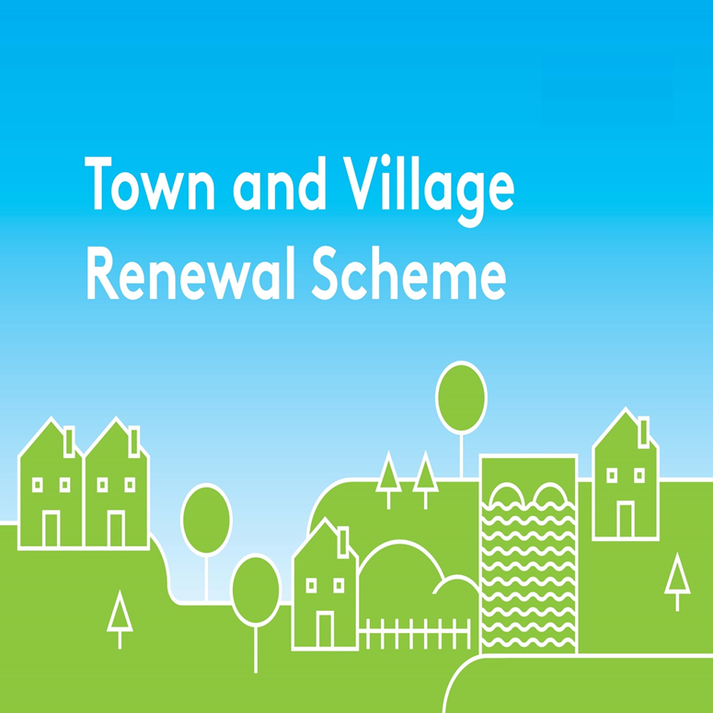
Please complete this Expression of Interest form
and return it to Community Department, Kilkenny County Council, Johns Green House, Kilkenny or by email to community@kilkennycoco.ie

Town & Village Renewal Scheme 2022

Town/Village covered:

Please indicate which category of funding is being applied for:

Category 1 Category 2 Category 2B

Towns/Villages with Towns/Villages with Towns/Villages with

Population of 5,000 Population of Population up to

or less 5,001-10,000 15,000

Amount of Funding Requested:

Applicant Group:

Applicant Contact Name:

Applicant Contact Address:

Applicant Telephone Number:

Applicant Mobile Number:

Applicant Email Address:

- Has funding for this project ever been sought from other sources? Yes No
(If "YES" yes please specify from what source and if funding was provided)

- Who are the specific project stakeholders/community partners in this project?
(Chamber of Commerce, Community group, etc.).

- Project details:
- If seeking funding of between €250,000 and €500,000, please detail the particular case for this level of funding.

- What is the objective of the proposed project and how will the intended outcomes be measured? (Please identify any metrics or benchmarks that will be applied).

DECLARATION
I hereby confirm that I have read and understand this document. I request that consideration be given in support of the project as outlined above.

Signature __________________________________________________

Position __________________________________________________

Date __________________________________________________

